**Reviewer Response**

We sincerely appreciate the work of the editorial team and referees in guiding the submission process and improving the manuscript quality.

**Editor:**

**E1.1:**

**Comment:**

*There is good interest in the work, but we'll look for the scores to improve upon revision and re-review for the paper to become acceptable.*

**Deputy Editor:**

**DE1.1:**

**Comment:**

*This manuscript has been reviewed by two experts in the field, both of whom recognize the potential importance of the findings. Both referees make a number of points that the authors should address in detail in a revised manuscript in order for the work to be considered further for publication in MRM.*

**Referee 1:**

**Comments to the Author:**

*This manuscript describes the application of ASL and ferumoxytol-based DCE MRI to study perfusion of the placenta in 10 rhesus macaques. The data set produced in this study is extremely valuable for characterizing flow though spiral arteries into the intervillous space. The experiments are very well motivated. However, the analysis does not allow the authors to reach very strong conclusions. This reviewer was left with many open questions, and possibly the impression that more could have been accomplished with the data obtained in this study. With analyses more directly focused to address how ASL and/or DCE MRI can address the clinical questions described in the Introduction and Discussion, it is my opinion that the Quality and Soundness of Conclusions would be improved substantially, and the Importance of the manuscript could be very high. Specific comments are as follows:*

**R1.1:**

**Comment:**

*The manuscript does not clearly state whether one method is the "gold standard" and is being used to validate measurements from the other, or whether the two methods are considered to be complimentary to each other. In either case, the specific measurements and interpretations obtained from each of the two measurements should be stated.*

**Response**:

In this study, ferumoxytol DCE is being used as the reference “gold-standard” to validate measurements by ASL FAIR. Unlike ASL, DCE has relatively high SNR and is less sensitive to slow arterial flow with no significant differences previously reported between ASL and DCE in renal blood flow (Cutajar et al. *European Radiology* 2014) and relative pulmonary blood flow (Lin et al. *Magn Reson Med* 2004) values. For these reasons, DCE is potentially more robust in slow perfusing organs (e.g. placenta) comparatively with ASL and will be considered the reference technique for perfusion in this study. DCE MRI is still well known to be prone to errors and is certainly not an absolute gold standard due to complex modeling and complications in converting signal to contrast concentration. The Abstract and Introduction sections have been revised to more clearly state this point (location: P4L11, P4L29).

**R1.2:**

**Comment:**

*There is discussion of the benefits of ASL relying on endogenous mechanisms of contrast, compared to ferumoxytol DCE MRI, which relies on injection of iron oxide. This seems to indicate the authors are using the DCE in rhesus macaques to validate the ASL (this is related to the above point). If that is the case, it would help if the authors identified the specific parameter, or parameters intended to be obtained with ASL, and whether conditions have been identified where ASL is reliable.*

**Response:**

The main goal of this study is to determine if the distribution of perfusion blood flow measures in DCE and ASL are similar. Ferumoxytol DCE is being used as the reference “gold-standard” to validate measurements by ASL FAIR. Both DCE and ASL have a long list of complexities that make absolute quantification challenging. In the DCE there are dependencies on this initial T1 of tissue, water exchange outside the distribution volume, non-linearities in signal to contrast, and challenges in absolute modeling (especially when considering the 4 potential arterial inputs). Conventional ASL analysis in organs with traditional capillary beds (e.g. brain, kidney, etc.) fit the ASL signal to a single-parameter implementation of the Buxton’s general kinetic model (Buxton et al. *Magn Reson Med* 1998). Given the unusual maternal vascular circulation within the intervillous space of the placenta and lack of voxel-wise tissue T1 maps for the placental tissue, absolute quantification of ASL data could have substantial errors. We have chosen to represent the ASL signal as an ASL ratio map, in units of percentage. This is a semi-quantitative parameter of the perfusion signal and will be directly proportional to the blood delivery to the placental intervillous space. The Methods section has been revised to more clearly state this point (location: P7L9).

**R1.3:**

**Comment:**

*The voxel-wise time course analysis of the DCE MRI data is specialized compared to more commonly used methods in studies using gadolinium-based contrast agents. If there is a reason why the Gd-based methods are not usable, it would help if it were stated.*

**Response:**

This animal study was multi-faceted. Ferumoxytol was used for purposes beyond the scope of this work (angiography, inflammatory response, 4D flow signal enhancement). DCE data was analyzed with a semi-quantitative method where perfusion metrics, such as contrast arrival time and relative blood flow were estimated by parametrizing the signal-time curve as a sigmoid-shaped logistic function (i.e. S-shaped curve with plateau). This choice fit the observed ferumoxytol DCE signal-time curves within the placental tissue with no appreciable contrast agent washout. Unlike alternative tracer-kinetic models, this approach is not sensitive to accurate measurement of the arterial input function, which is challenging to estimate in the placenta due to the multiple arterial inputs. The Methods section has been revised to more clearly state this point (location: P7L15).

**R1.4:**

**Comment:**

*Figures 2 and 4 show considerable similarities between ASL ratios and contrast arrival times, but both parameters appear quite dis-similar to the uptake slope. How does the slope information inform the interpretation of the ASL data? Are the differences between slope and arrival time anticipated? It would be helpful if the authors could lead the reader through any conclusions that could be drawn from the differences (or similarities) between the slope and arrival time.*

**Response:**

Most animals showed similar regions of high ASL ratios, early contrast arrival time, and higher uptake slope. This result was anticipated since blood delivery through the spiral arteries should have the highest velocity and slow down upon entering the intervillous space. However, in Figures 2 and 4, some regions with ASL ratio and early arrival time are adjacent to regions with higher uptake slope. Additionally, some regions with high uptake slope do not have early contrast arrival time or high ASL signal. This may be physiological with more complex flow patterns within the intervillous space being measured such as a narrow portion of the placental tissue where ferumoxytol contrast quickly fills. Regions with high ASL signal and long contrast arrival times may be potentially from fetal perfusion. ASL FAIR analysis ignores contributions from fetal circulations and may overestimate placental perfusion as a result. Long acquisition times may have contributed to through-plane placental tissue movement between the ASL and DCE acquisitions which may not be corrected for in the image registration steps. Errors between the volume-to-slice registration of placental tissue in the ASL and DCE data could therefore result in spatial differences between the ASL signal, contrast arrival time, and relative blood flow. The Discussion section has been revised to more clearly state this point (location: P11L1, P14L5).

**R1.5:**

**Comment:**

*The strong focus on the differences between +OVS and -OVS for the ASL is one aspect of the study that was not as carefully motivated. Is there a reason that OVS would be considered particularly critical in placental studies? If so, is it important to present the -OVS data in such detail?*

**Response:**

ASL signal has potential contributions from both blood signal that has left the vasculature and perfused into tissue and from blood signal remaining within the vasculature. To mitigate this, the temporal bolus width of the FAIR-labeled spins can be defined using saturation RF pulses. After FAIR labeling, saturation pulses are played out after a specified delay time outside of the imaging plane as was first introduced in the brain with inferior saturation RF pulses in the QUIPSS II or Q2TIPS methods (Wong et al. *Magn Reson Med* 1998; Luh et al. *Magn Reson Med* 1999). The effect of the saturation pulses in ASL FAIR signal within the placenta is currently unexplored. We use proximal or outer volume saturation (OVS) pulses in this study to limit the bolus width from the multiple arterial input sources to the placenta. By “shaping” the temporal width ASL bolus with the OVS pulses, the ASL signal contributions should be only from blood signal that has left the vasculature. We have clarified terminology of the OVS RF pulses and have updated the manuscript to define the acronym as outer volume saturation (OVS) pulses instead of outer volume suppression pulses, to avoid potentially confusing readers.The Abstract, Introduction, and Methods sections have been rewritten in the updated manuscript (location: P2L5, P3L28, P6L8).

**R1.6:**

**Comment:**

*It came as a surprise in the Methods that there are 3 treatment groups in the 10 monkeys. The manuscript might be easier to follow if the treatment groups are mentioned in the Introduction and Discussion. Do the authors conclude that placental perfusion is not affected by IL-B exposure?*

**Response:**

Intra-amniotic fluid injection of interleukin-1 beta (IL-1β) has previously been shown to induce chorioamnionitis and preterm labor in the rhesus macaque (Sadoskey et al. *Am J Obstet Gynecol* 2006; Presicce et al. *Biology of Reproduction* 2015). We performed the IL-1β infusion to induce an inflammation response and promote immune cell trafficking, but that was not the focus of the work presented here. Instead, the induced inflammation response could potentially disrupt perfusion. We hypothesize that acute inflammation may also perturb placental intervillous perfusion, measurable by MRI methods. This study has very small numbers with a total of 10 animals and sub-analysis of the groups should be considered preliminary. However, no statistically significant differences were observed between the IL-1β injected group (*N*=4) and the two control groups (*N*=3 in both saline injected and no injection) in the ASL perfusion measurement (ASL ratio [%]) or DCE perfusion measurements (contrast arrival time [sec.] and relative blood flow [sec.-1]. The authors have updated the Introduction and Discussion Sections to reflect the conclusion that in this small, preliminary study placental perfusion was not affected by IL-1β exposure in the rhesus macaque (location: P5L1, P10L13, P14L14).

**R1.7:**

**Comment:**

*Ultimately, it would be interesting to know if the results of the ASL measurements can be predicted from the DCE MRI, or vice versa. Or, are there conditions where the sensitivity profiles of the measurements are qualitatively different? For example, for regions of the placenta that have DCE MRI arrival times greater than 2 seconds, is the ASL data uninformative? If so, what percentage of spiral arteries are characterized by arrival times of less than 2 seconds? It is not possible to infer the answers to these questions from the weak but significant correlations reported in Figures 5-7.*

**Response:**

The early arrival portions of the DCE data may be able to predict the locations of ASL and vice versa but distal portions of the placenta where slow uptake was observed by DCE, noise predominates the ASL FAIR ratio images. The ASL data is likely uninformative beyond the immediate vicinity of the spiral arteries. There are limitations since ASL FAIR data is not a 3D or 2D multi-slice acquisition. The ASL FAIR data represents a single slice acquisition where 3D volumetric coverage of the placenta would be desirable. Thus, a limited representation of entire placental perfusion is shown. Full placental coverage may allow us to answer the question of what percentage of spiral arteries have fast (<2 sec) arrival times and which do not. The authors have updated the Discussion section to reflect these points (location: P11L9, P14L1).

**Referee 2:**

**Comments to the Author:** *Very interesting to me. The two datasets agree nicely in that the ASL only shows signal in areas of rapid contrast agent transit time. But I think the conclusions are weak.*

**R2.1:**

**Comment:**

*You don’t strongly compare the two ASL measures: which should we use? Or what do they tell us different?*

**Response:**

Additional saturation RF pulses (e.g. QUIPSS II and Q2TIPS) have previously been shown to minimize systematic error caused by variable transit time of labeled blood and remove contaminating intravascular signal from labeled blood in the imaging slice for brain applications (Wong et al. *Magn Reson Med* 1998; Luh et al. *Magn Reson Med* 1999). Here, we have applied saturation pulses to the tagging region above and below the imaging slice to limit the width of the blood ASL bolus. We have provided semi-quantitative perfusion results showing ASL FAIR with OVS RF pulses performs better than ASL FAIR in suppressing remaining macrovasculature signal that has not perfused into the placental tissue. The ASL FAIR with OVS reduced the artefactual, hyper-intense perfusion signal particularly on the periphery of the placental tissue. Limiting the ASL bolus width is recommended for ASL FAIR for quantification. As a result, quantifying ASL FAIR signal without the OVS pulse, ASL FAIR may overestimate perfusion with potentially contributions from both perfused blood signal in the placenta and blood signal remaining within the vasculature. However, VSASL or IVIM may be better alternatives to ASL FAIR due to reduced dependence on the long transit time. The authors have updated the Discussion section to reflect these points (location: P11L16 and R13L17).

**R2.2:**

**Comment:**

*What about contrast agent v ASL?*

**Response:**

Most animals showed similar regions of high ASL ratios, early contrast arrival time, and higher uptake slope. This result was anticipated since blood delivery through the spiral arteries should have the highest velocity and slow down upon entering the intervillous space. However, in Figures 2 and 4, some regions with ASL ratio and early arrival time are adjacent to regions with higher uptake slope. Additionally, some regions with high uptake slope do not have early contrast arrival time or high ASL signal. This may be physiological with more complex flow patterns within the intervillous space being measured such as a narrow portion of the placental tissue where ferumoxytol contrast quickly fills. Regions with high ASL signal and long contrast arrival times may be potentially from fetal perfusion. ASL FAIR analysis ignores contributions from fetal circulations and may overestimate placental perfusion as a result. Long acquisition times may have contributed to through-plane placental tissue movement between the ASL and DCE acquisitions which may not be corrected for in the image registration steps. Errors between the volume-to-slice registration of placental tissue in the ASL and DCE data could therefore result in spatial differences between the ASL signal, contrast arrival time, and relative blood flow. The Discussion section has been revised to more clearly state this point (location: P11L1, P14L5).

**R2.3:**

**Comment:**

*I do think the contrast agent transit times are interesting.. can you compare with literature.. others have used these agents in placentas.. even in humans, I assume someone has quoted transit times.*

**Response:**

The extended transit time across the placental region from ferumoxytol DCE images, with an average of 34 sec, are similar to that observed by others using MRI with gadolinium in the rhesus macaque (Panigel, Wolf et al. 1988, Frias, Schabel et al. 2015) and with iron in mice (Deloison, Siauve et al. 2012). Though specific contrast arrival times were not reported on a voxel-wise basis, the contrast arrival times to the placenta appear to be approximately 10’s of seconds, with distant portions taking upwards of 1 min. Using X-ray film, Martin et al. showed dye arriving to the primary and secondary lobes of the macaque placenta in 2 and 6 seconds after injection via the femoral artery. The dye was then observed to exit the placenta via the umbilical vein 11 seconds after injection. The cotyledon structure became “observable” by 15 and 18 seconds, suggesting long contrast arrival times to distal portions of the placenta (Martin, Ramsey et al. 1966). In humans, Burchell demonstrated 2-3 sec arrival times of contrast dye into the intervillous space after injected through an aorta catheter (Burchell 1967). He noted that diffusion of the dye took roughly 30 seconds in late-gestational stage women and diffusion rate of the dye was dependent on the spiral artery and location within the placenta. Similarly, Borell et al. quoted “first seen” dye contrast into the intervillous space in humans on the order of 3-11 sec and qualitatively described filling at more distal portions of the placenta (Borell, Fernstroem et al. 1965). Qualitatively, Marcos and Semelka showed partial placental tissue enhancement by gadolinium dynamic MRI immediately after injection and full tissue enhancement at 45 seconds post injection (Marcos, Semelka et al. 1997). The longer arrival times reported in this study are likely due to the slow venous injection of ferumoxytol over 20 seconds resulting in contrast dispersion coupled with the sigmoid shaped fitting. Since the contrast arrival time was calculated at the point of 50% enhancement, slow enhancement would lead to extended estimates of the contrast arrival. The Discussion section has been revised to more clearly state this point (location: P12L13).

**R2.4:**

**Comment:**

*You say the transit times of up to 70 s (is this correct- it is an important result if so, I do think it is possible given the slow flows we have detected with other methods in some parts of the placenta but just checking.. ) If they are 70 s then it is really no surprise the ASL signal is low in much of the placenta. This now answers a question that has been in my mind for some time: ASL or DWI for placental perfusion? DWI has the advantage of not depending on transit time which might be crucial in parts of the placenta. (It doesn’t require random motion, it only requires incoherence over a voxel)*

**Response:**

In distal portions of the placenta, the contrast arrival times are upwards of 70 seconds from the injection time to completely fill as measured by the ferumoxytol DCE data. These times would preclude measurement by spatially-based ASL methods due to loss of ASL label governed by the T1 of blood (T1 = ~1.6 sec at 3T). As suggested, DWI does have the advantage of not being dependent on transit time. VSASL or IVIM may be better alternatives to ASL FAIR due to reduced dependence on the long transit time. Spatially based ASL methods may still prove valuable in measuring blood flow to the intervillous space immediately near the vicinity of spiral arteries and/or located the spiral arteries within the placenta. Spiral artery remodeling during pregnancy is essential to maximize the delivery of maternal blood to the intervillous space at suitably low velocity (Espinoza et al. *J Perinat Med* 2006). Maladaptation of the spiral arteries has been associated with several gestational complications including pre-eclampsia and intrauterine growth restriction (Olofsson et al. *Eur J Obstet Gynecol Reprod Biol* 1993; Aardema et al. *Placenta* 2001.). Given the comparisons in this study and these results, it is conceivable that the distribution of early arriving blood is sufficient to determine the overall health of the placenta. However, in defining the pathogenesis, it must be considered that the ASL signal may not fully represent the perfusion signal. The Discussion section has been revised to more clearly state these points (location: P11L30, P13L17).

**R2.5:**

**Comment:**

*In abstract and introduction you should explain why OVS was used/investigated (to suppress intravascular /early arriving contribution I think)*

**Response:**

ASL signal potentially has contributions from both blood signal that has left the vasculature and perfused into tissue and from blood signal remaining within the vasculature. To mitigate this, the temporal bolus width of the FAIR-labeled spins can be defined using saturation RF pulses. After FAIR labeling, saturation pulses are played out after a specified delay time outside of the imaging plane as was first introduced in the brain with inferior saturation RF pulses in the QUIPSS II or Q2TIPS methods (Wong et al. *Magn Reson Med* 1998; Luh et al. *Magn Reson Med* 1999). The effect of the saturation pulses in ASL FAIR signal within the placenta is currently unexplored. We use proximal or outer volume saturation (OVS) pulses in this study to limit the bolus width from the multiple arterial input sources to the placenta. By “shaping” the temporal width ASL bolus with the OVS pulses, the ASL signal contributions should be only from blood signal that has left the vasculature. We have clarified terminology of the OVS RF pulses and have updated the manuscript to define the acronym as outer volume saturation (OVS) pulses instead of outer volume suppression pulses, to avoid potentially confusing readers.The Abstract and Introduction sections have been rewritten in the updated manuscript (location: P2L5, P3L28, P6L8).

**R2.6:**

**Comment:**

*I think figure S1 should be included and not be a supplementary figure. The colour coding in figures S1c and d are confusing- just a line at 1 or at0 and 1 (I think that is what is intended) would do.. or say red means inverted and grey means saturated. It would be better to show actual blood signal from assumed blood T1. If you did this the caption could probably be shortened too! [Is this figure the right way round.. after the selective inversion inverted blood will start to flow in, after the OVS saturated blood will flow in – and this fits with the data which shows feeding areas are not visible on OVS+ scans- shouldn’t the grey and red boxes in 1d be swapped]*

**Response:**

We have moved the supporting figure 1 into the main manuscript to be included as Figure 1. Simplified MRI pulse sequence diagrams are shown for both the ASL FAIR acquisitions without (**a**, -OVS) and with (**c**, +OVS) outer volume saturation (OVS) RF pulses. Inverted or FAIR labeled spins are represented by the red color while saturated spins are represented by the gray color. The theoretical ASL signal is shown for the –OVS (**b**) and +OVS (**d**) cases as a function of the blood spins arrival time from labeling region to the placental tissue at two time points during the pulse sequence: immediately after inversion (0 sec) and at imaging readout (TI=2.0 sec). The remaining ASL signal is governed by assuming a T1 decay of labeled blood and constant blood flow from the labeling region into the imaging slice. The OVS pulses serve to saturate macrovascular signal in the imaging region and this is depicted as removing the ASL signal with the +OVS schematic. The updated Figure 1 can be seen below. The Figure, Figure caption, and methods section have been changed to reflect this edit in the updated manuscript (location: P6L13, P17L42).

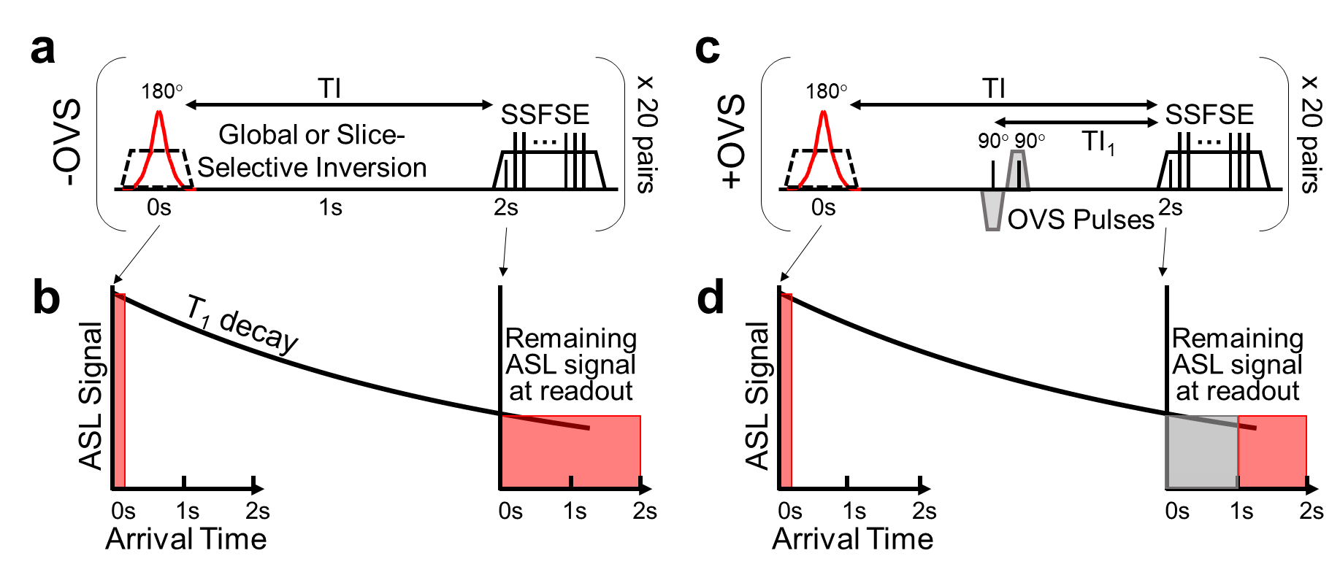

**R2.7:**

**Comment:**

*ASL slice thicknesses not given, and the difference between readout slice and selective inversion not given (there will be one). This will be important to interpreting results.*

**Response:**

The readout slice thickness was 4 mm and the selective inversion slice thickness was 14 mm. This oversight has been included in the updated manuscript (location: P4L1).

**R2.8:**

**Comment:**

*Is it justified to assume that the factor linking OVS+ and OVS- is just a factor of 2? Surely there are other factors like t1 recovery, and volume occupied at those transit times?*

**Response:**

In both ASL FAIR pulse sequences, the post-labeled delay (or inversion time (TI) from the inversion label to the imaging readout is 2.0 seconds. The outer volume saturation (OVS) pulses are played out proximal to the imaging slice 1.0s after the inversion label to define an ASL temporal bolus width of 1.0 seconds (sometimes called the TI1 time). In the -OVS case, TI1 = TI. If we assume an identical T1 recovery of arterial blood (T1,blood) in both the +OVS and -OVS cases, the resulting ASL signal in should only be different by a factor of 2 using the equation below (Alsop et al. *Magn Reson Med* 2015) were $∆M$ is the signal difference between the control and tagged ASL images, $M_{0}$ is the proton-density weighted image.

$$ASL Signal ∝\frac{∆M}{M_{0}}∙\frac{exp⁡(\frac{TI}{T_{1,blood}})}{{TI}_{1}}$$

The Methods section has been expanded upon in the updated manuscript to clarify this point (location: P7L7).

**R2.9:**

**Comment:**

*Figure 3: the box and whisker plot would be better augmented showing individual subjects joined for both conditions as this will let you see trends between sequences.*

**Response:**

Figure 3a (Figure 4a in the updated manuscript) has been re-plotted to show the individual animals grouped by each intervention. The revised Figure 3A is shown below. The Results section has been changed in the updated manuscript (location: P7L4, P18L20).

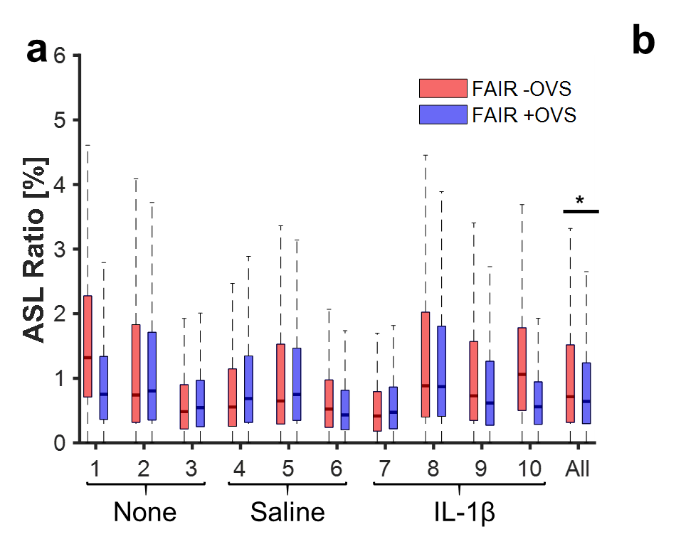

**R2.10:**

**Comment:**

*I do not understand figure 3b: why the cut off at a ratio of 15% for the –OVS condition. And why are the circled points those showing reduced ASL on OVS? Surely it is all the points below the line and that is why the line of identity goes near the top of most of the data points.*

**Response:**

Figure 3b (Figure 4b in the updated manuscript) shows a voxel-wise comparison of the ASL FAIR data (as the ratio map values [%]) between the +OVS and -OVS. We expect a downward shift of the highest intensity ASL FAIR –OVS values which likely represent intravascular spins. After normalizing the ASL FAIR data to the TI1 or TI (see comment to R2.8) or ASL bolus width, the high ASL ratio values were lowered in the case with the OVS pulses. The display cutoff has been changed to 25% to best display the entire dynamic range of the ASL FAIR data since no values in the ASL FAIR +OVS were greater than 25%. The circled points highlight many of the voxels with very high ASL FAIR ratio (hyper-intense intravascular signal) which were lowered with the OVS pulses. The revised Figure 3b (Figure 4b in the updated manuscript) is shown below.

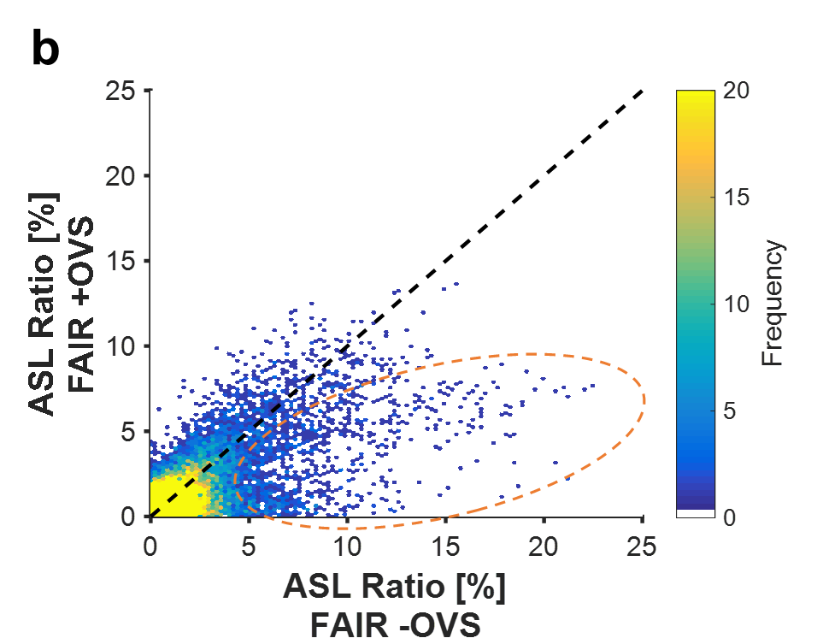

**R2.11:**

**Comment:**

*P9 line 49: no contrast agent was detected in fetus or amniotic fluid: This is so important please can you give the % change in signal in both of these tissues averaged across all subject.*

**Response:**

The percent change in the signal intensity between the initial time point and final time point of the 4D DCE data was calculated by drawing a region-of-interest on both the fetus and amniotic fluid. A non-significant signal intensity change was measured to be -0.6 ± 3.0% for fetal tissue (*p*=0.52) and 1.9 ± 8.8% for the amniotic fluid (*p*=0.59) averaged across all animals in the study. The Abstract, Methods, Results, and Discussion sections have been expanded upon in the updated manuscript to highlight this result (location: P2L12, P8L5, P9L19, P12L24).

**R2.12:**

**Comment:**

*Figures 6 and 7 can be combined to allow another image. If for figures 6 and 7 you want to use Wilcoxon Rank Sum – I’m not sure how it could be applied to this data – doesn’t it need to be paired in some way. .what is the pairing here. I must be missing something, so what I am about to write doesn’t make sense to me but hopefully you can interpret it as you do know what these figures show: With the sum rank test then rather than just box and whisker plots (which never show trends between groups) you need to show individual subject data linked by lines.*

**Response:**

Figures 6 and 7 have been combined (Figure 7 in the updated manuscript). Here, we used the Wilcoxon rank-sum test, also known as the Mann-Whitney U test that is not the same as the Wilcoxon signed-rank test. The Wilcoxon rank sum test does not require data pairing but the Wilcoxon signed rank test does require pairing. The Results section and Figure caption have been updated to reflect the figure change (location: P10L5, P19L5).

**R2.13:**

**Comment:**

*You talk about motion in IVIM and VSASL but what about motion in the methods used here?*

**Response:**

Bulk-motion can also be problematic for pulsed ASL (e.g. FAIR) and DCE MRI acquisitions confounding resulting and/or creating image artifacts, however, IVIM and VSASL are sensitive to much lower levels of motion. In this study, maternal respiratory motion was considered the potentially primary source of bulk motion. Due to anesthesia, negligible fetal motion was qualitatively observed throughout the duration of the ASL and DCE acquisition. The DCE acquisition used a respiratory-gated, acquisition known as DISCO (Saranathan et al. *J Magn Reson Imaging* 2012) that reconstructs images using pseudo-randomly acquired segmented portions of k-space. The pseudorandom sampling, similar to radial, reduces motion blurring and other motion-related artifacts. These effects are likely small though given the regularity of maternal breathing under anesthesia and were not observable in image. The spatially selective ASL acquisitions rely on labeling and imaging of targeted regions potentially affected by motion. A TI of 2.0 sec was specifically chosen to coincide with the maternal respiratory rate. The choice of TI ensured the labeling and imaging region were in an identical respiratory phase and physical location, in the case of the slice-selective inversion. Furthermore, image registration was performed during post-processing to mitigate remaining maternal motion. More advanced motion management techniques, reviewed elsewhere (Malamateniou et al. *AJNR Am J Neuroradiol* 2013), may be needed in clinical settings where anesthesia is not commonly used and fetal motion is potentially much more significant. The Discussion section has been expanded upon in the updated manuscript to clarify this point (location: P13L21).

**R2.14:**

**Comment:**

*P8 line 17 the asl ratio’s : no apostrophe needed*

**Response:**

Thank you for the correction. This oversight has been corrected in the updated manuscript (location: P9L4).